Multiple choice section

Question 1 [6.1]

Which of the following is the same as 85 cm?

A 850 m B 8.5 km C 8.5 mm D 850 mm

Question 2 [6.2]

The perimeter of a rectangle of length 7 cm and width 60 mm is:

A 26 cm B 42 mm C 42 cm D 26 mm

Question 3 [6.6]

Assuming that each cube represents 1 cm3, the volume of the following object in cm3 is:

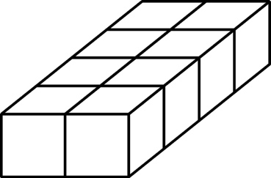

A 8 cm3 B 4 cm3 C 10 cm3 D 12 cm3

Question 4 [6.3]

A square of area 49 m2 has side length:

A 5 m B 7 m C 8 m D 9 m

Question 5 [6.1]

Which metric unit would be most appropriate for measuring the distance from Perth to Melbourne?

A metres B kilometres C centimetres D millimetres

Question 6 [6.1]

Which set of lengths are in ascending order?

A 7.7 m, 700 cm, 7 km, 70 m B 70 m, 700 cm, 7.7 m, 7 km

C 700 cm, 7.7m, 70 m, 7 km D 7 km, 7.7 m, 700 cm, 70 m

Question 7 [6.3]

Which metric unit would be most suitable for measuring the area of a playing card?

A mm2 B litres2 C m3 D km2

Question 8 [6.3]

The shape has been drawn on centimetre grid paper. Estimate its area.

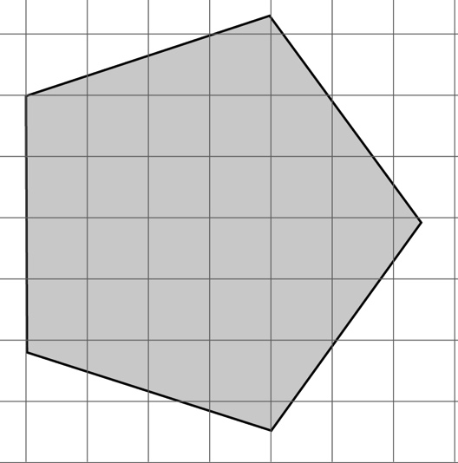

A 22 cm2 B 28 cm2 C 30 cm2 D 34 cm2

Question 9 [6.4]

A parallelogram with a base of 11 cm, and a perpendicular height of 5 cm has an area of:

A 32 cm2 B 55 cm2 C 5.5 cm2 D 24 cm2

Multiple-choice total marks: ____ / 9

Short answer section

Question 10 3 marks [6.1, 6.4, 6.6]

Use words from the list below to complete the following sentences.

multiply divide base height length breadth

(a) To convert from a larger unit of measurement to a smaller unit of measurement, you need to ____________________.

(b) The area of a parallelogram is calculated by multiplying the base by the perpendicular _____________.

(c) The volume of a rectangular prism is the product of its ____________, width and height.

Question 11 3 marks [6.1]

Complete the following conversions.

(a) 12.903 km = __________ m

(b) 76.4 mm = _________ cm

(c) 341 mm = __________ m

Question 12 2 marks [6.1]

The Richmond bridge in Tasmania is 41 m long and the Ted Smout bridge in Queensland is 2740 m long. Convert these dimensions to kilometres, correct to 2 decimal places.

Question 13 3 marks [6.1]

Monique is knitting a scarf. If, at the end of Monday the scarf measures 200 mm long and she can knit 15 cm in a day, how long is the scarf at the end of Saturday (in centimetres)?

Question 14 2 marks [6.2]

An isosceles triangle has a perimeter of 380 mm. If the base is 146 mm, find the length of the  
other two sides.

Question 15 3 marks [6.2]

A rectangle has sides where the length is double the width. If the perimeter is 360 cm, what are the dimensions of the rectangle?

Question 16 3 marks [6.3]

Rahul has a rectangular backyard. In the middle is a pool measuring 12 m by 2 m. There is a 1 m wide path around the pool. Finally, there is a garden 2 m wide around the path. Draw a diagram of Rahul’s backyard and then calculate the total area .

Question 17 2 marks [6.3]

Find the area of the following.

(a) A square with side lengths of 1.2 cm.

(b) A rectangle with length of 5.2 cm and width of 6 cm.

Question 18 3 marks [6.3]

A window has a height of 0.9 m and is 500 mm wide. A pleated curtain is to be made for the window.  
The material for the curtain needs to be three times the width of the window and have a drop (length) of 30 cm longer than the window. How much material is required to make the curtain (in square metres)?

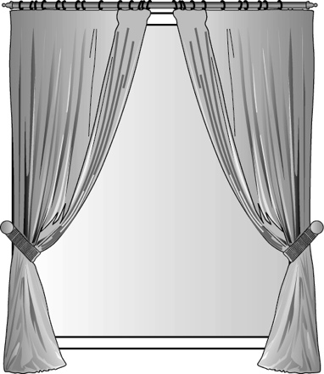

Question 19 2 marks [6.4]

A parallelogram has a base length of 8 cm and an area of 72 cm2. What is the height of the parallelogram?

Question 20 4 marks [6.5]

Calculate the area of the following shape.

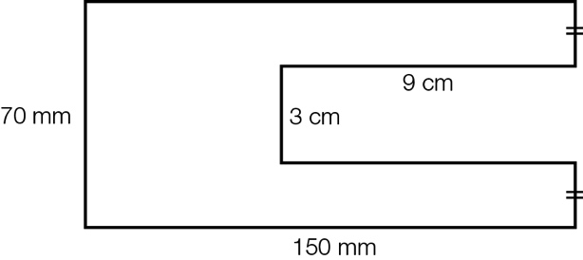

Question 21 2 marks [6.5]

Find the area of the triangle.

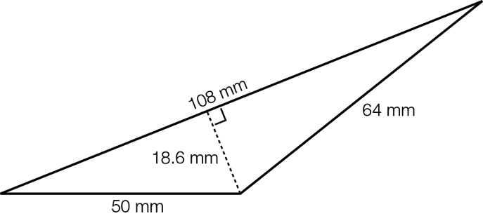

Question 22 3 marks [6.5]

Find the area of the following composite shape.

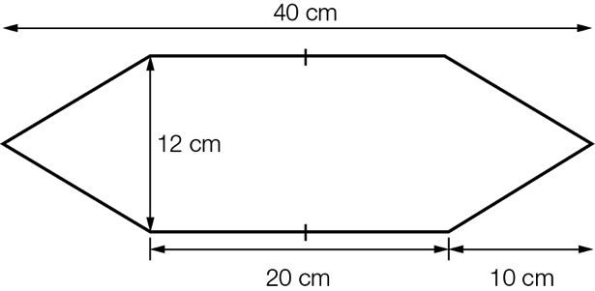

Question 23 3 marks [6.5]

Find the shaded area.

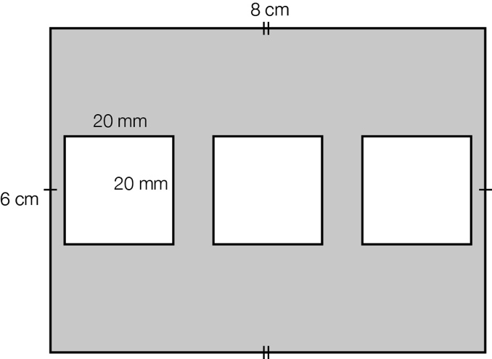

Question 24 2 marks [6.6]

Find the volume of the rectangular prism.

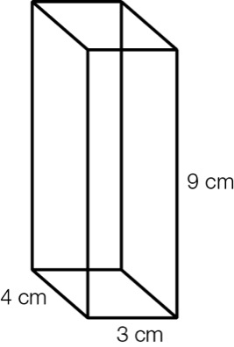

Question 25 3 marks [6.6]

A rectangular prism has a volume of 105 cm3. If its length is 7 cm and its width is 5 cm, what is   
its height?

Question 26 3 marks [6.5]

Kimberly is making a mosaic table top. If the table top measures 900 mm by 900 mm and each square tile has a side length of 2 cm, how many tiles are required to cover the table top?

Short answer total: _________ / 46

Extended answer section

Question 27 5 marks [6.6]

(a) A carton contains exactly 18 boxes of soap. If the dimensions of one soap box are 150 mm by 60 mm by 110 mm, what is the volume of the carton?

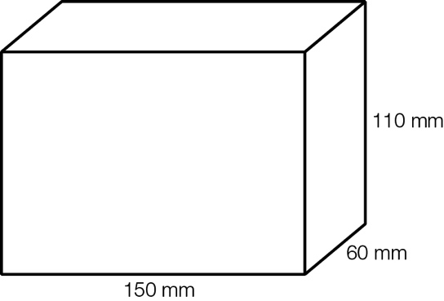

(b) If the soap boxes are stacked two high in the carton, what are the possible dimensions of the carton (in mm)?

Question 28 3 marks [6.2, 6.3]

The following rectangle has an area of 18 cm2 and a perimeter of 18 cm. Find another rectangle that has the same numerical value for the both its area and its perimeter.

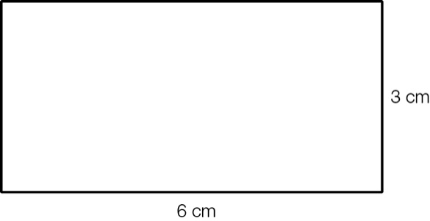

Question 29 4 marks [6.5]

Andrew wants to cover a wall with some art work. He wants to buy three canvases of the same size. Andrew’s wall measures 2.4 m in height and 4 m wide. The canvases are to be placed with a 10 cm gap between each canvas and the ends of the wall.

(a) Which canvas from the list below will be the best fit? (Andrew wants to use most of the wall.)

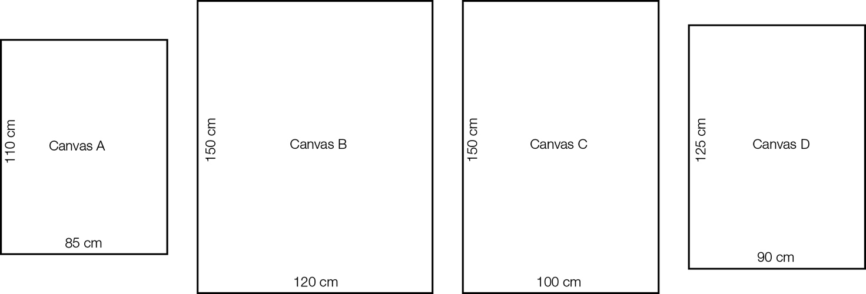

(b) What is the total area that the three canvases will cover?

Question 30 6 marks [6.2]

A coach tells his team to run around the soccer field 12 times. The coach also gave the option of running around half the field 18 times but he did not say which half. If the field has a length of 110 m and a width of 65 m, find:

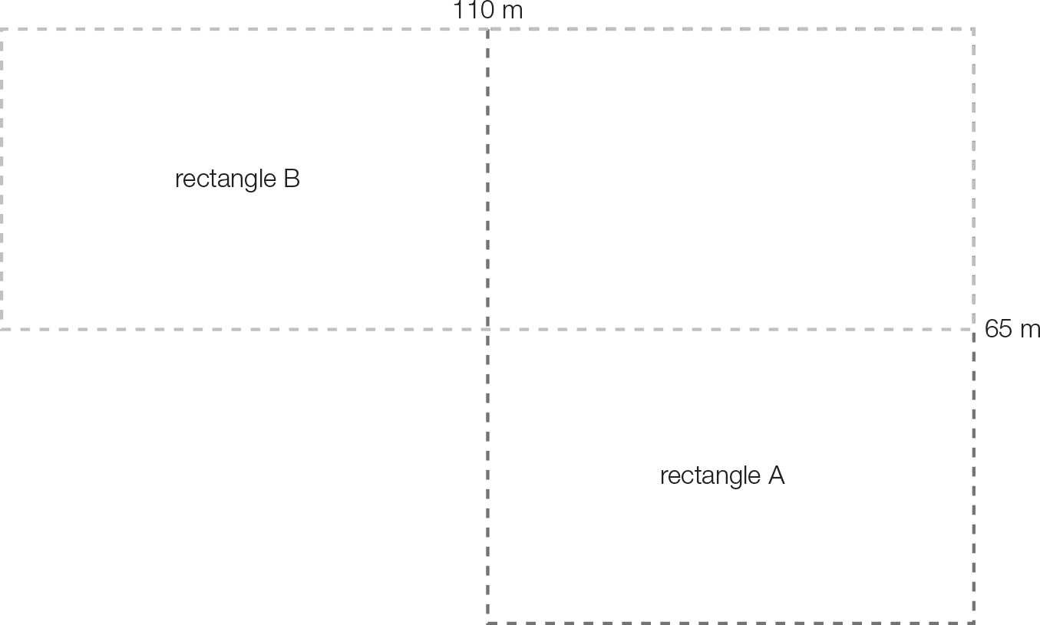

(a) the distance covered by those who ran 18 laps of rectangle A

(b) the distance covered by those who ran 18 laps of rectangle B

(c) the distance covered by those who ran 12 full laps.

Extended answer total: _________ / 18

TOTAL test marks: _______ / 73